This week I mainly complete the M2 and the test of the whole module, which are used to transform the data in parallel to the data in serial. At the same time, I write a SPI master module and test it.

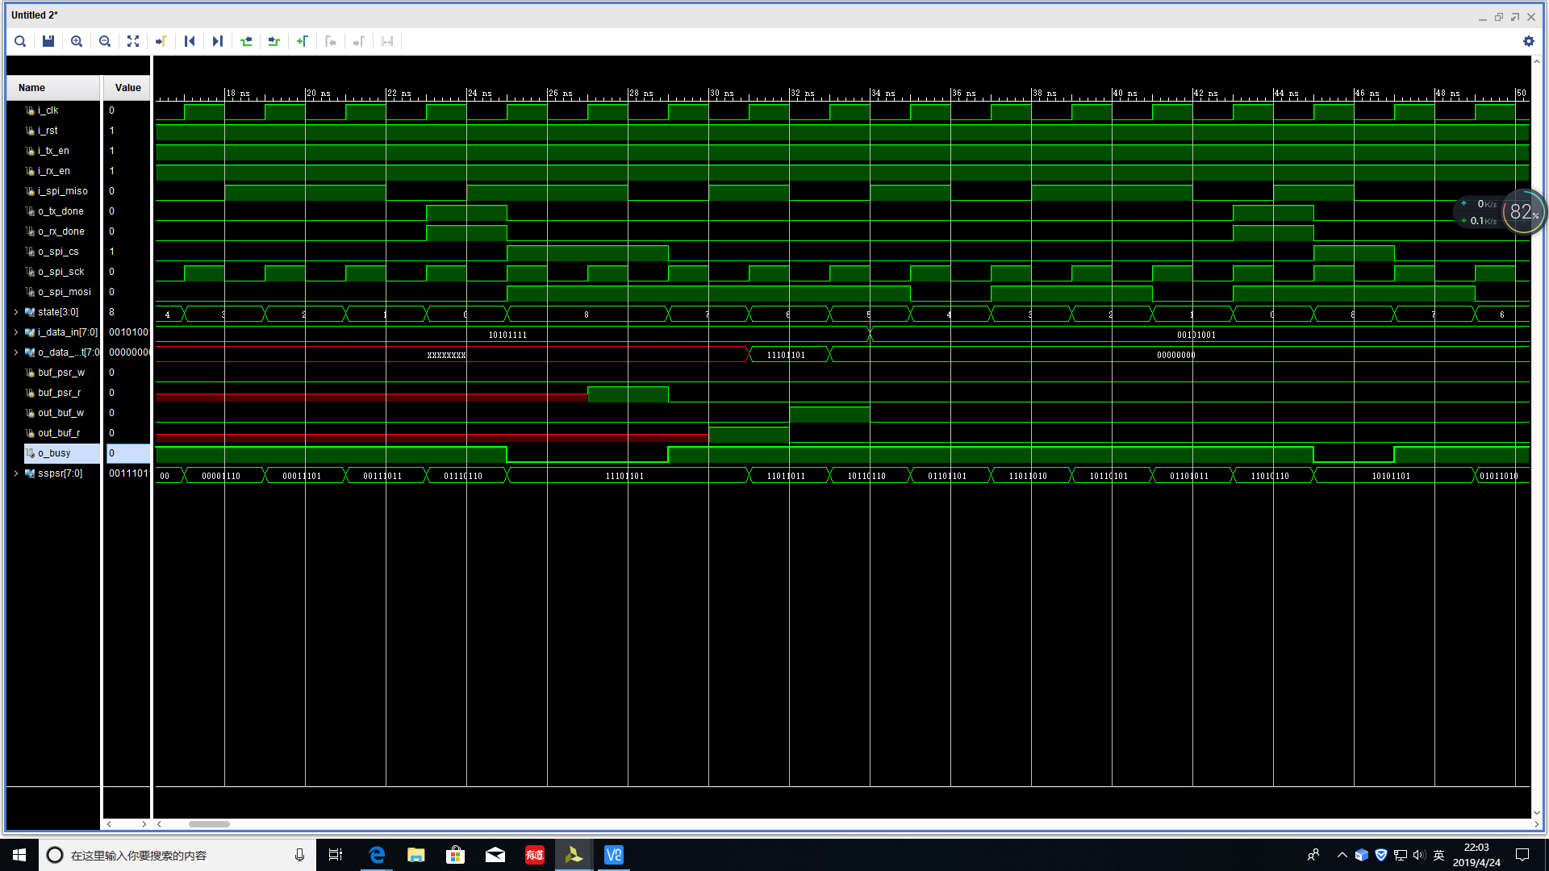

This is the simulation of the SPI master

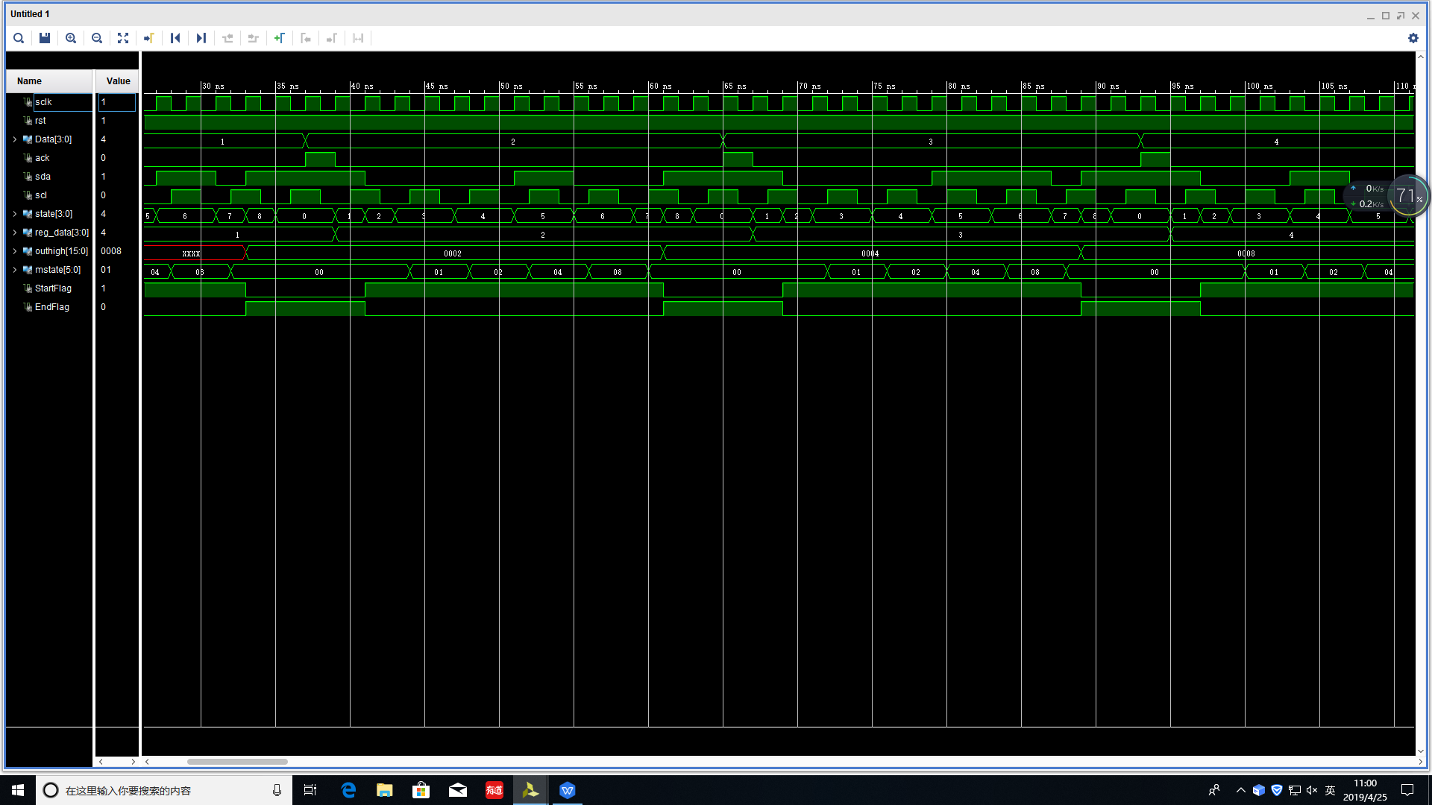

This is the simulation of the M2.